Dis-Asia- Indus Valley mother goddess

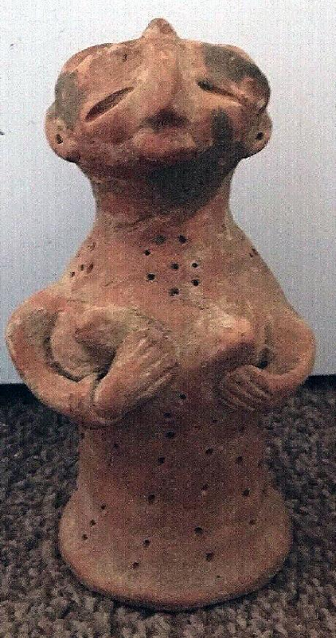 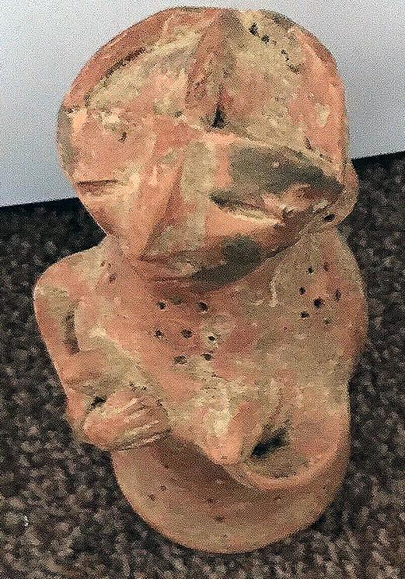 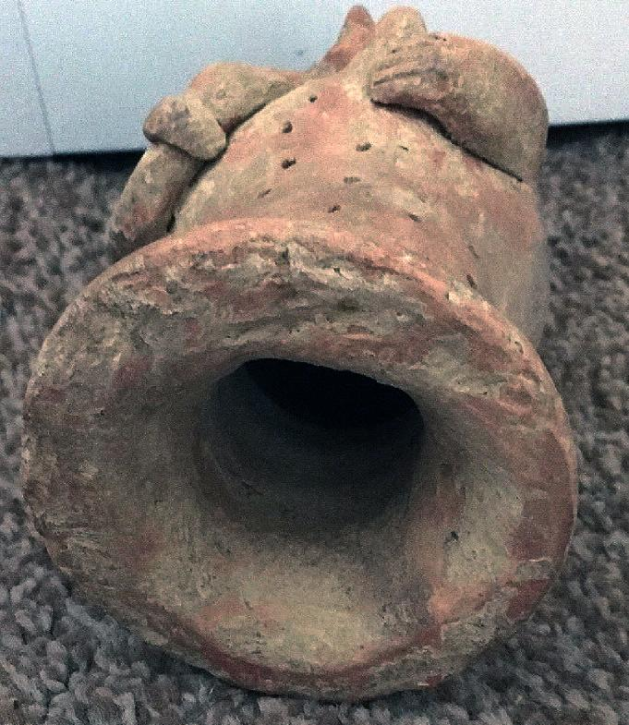 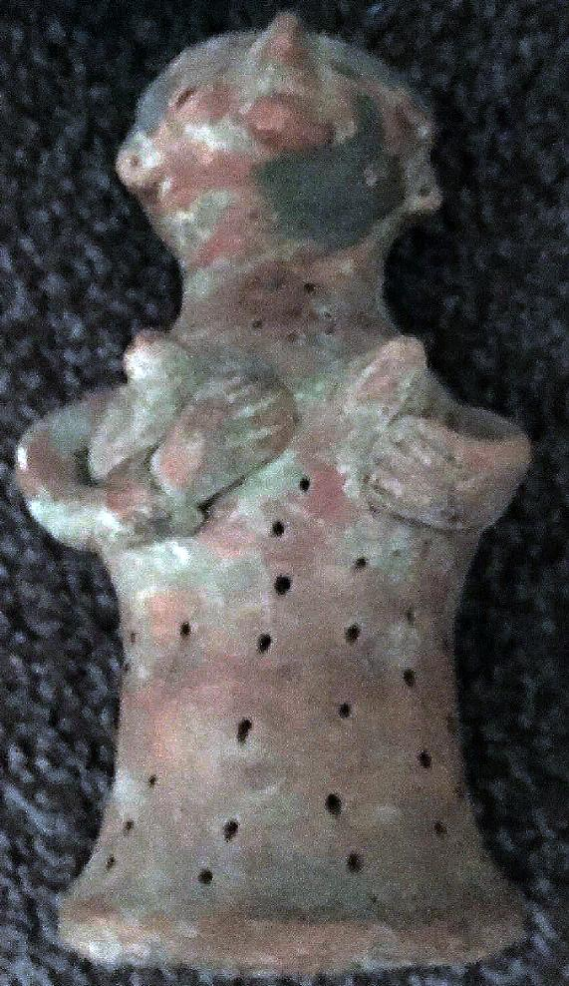

Formal Label: Indus Valley mother goddess

Accession Number:

Date or Time Horizon: 2000 BCE

Geographical Area: Pakistan

Cultural Affiliation: Indus

Medium: terracotta

Dimensions: H 20cm X D 9cm

Weight:

Provenance: part of an old collection

Very rare Indus Valley mother goddess with lots 2000bc

Size 20cm X 9cm part of an old collection

Complete no cracks